MLOPS TASK 1

I have created a local repo and created the code and pushed it to github

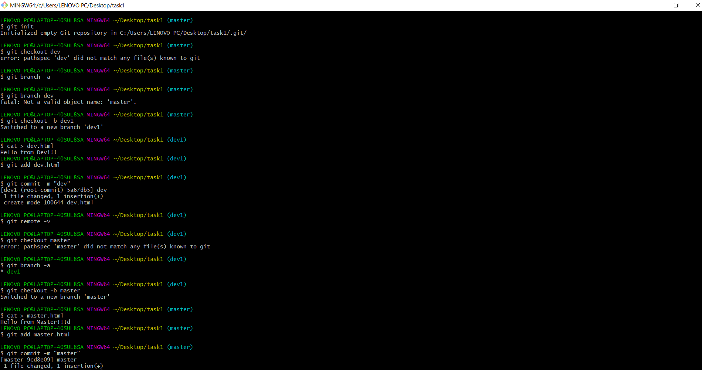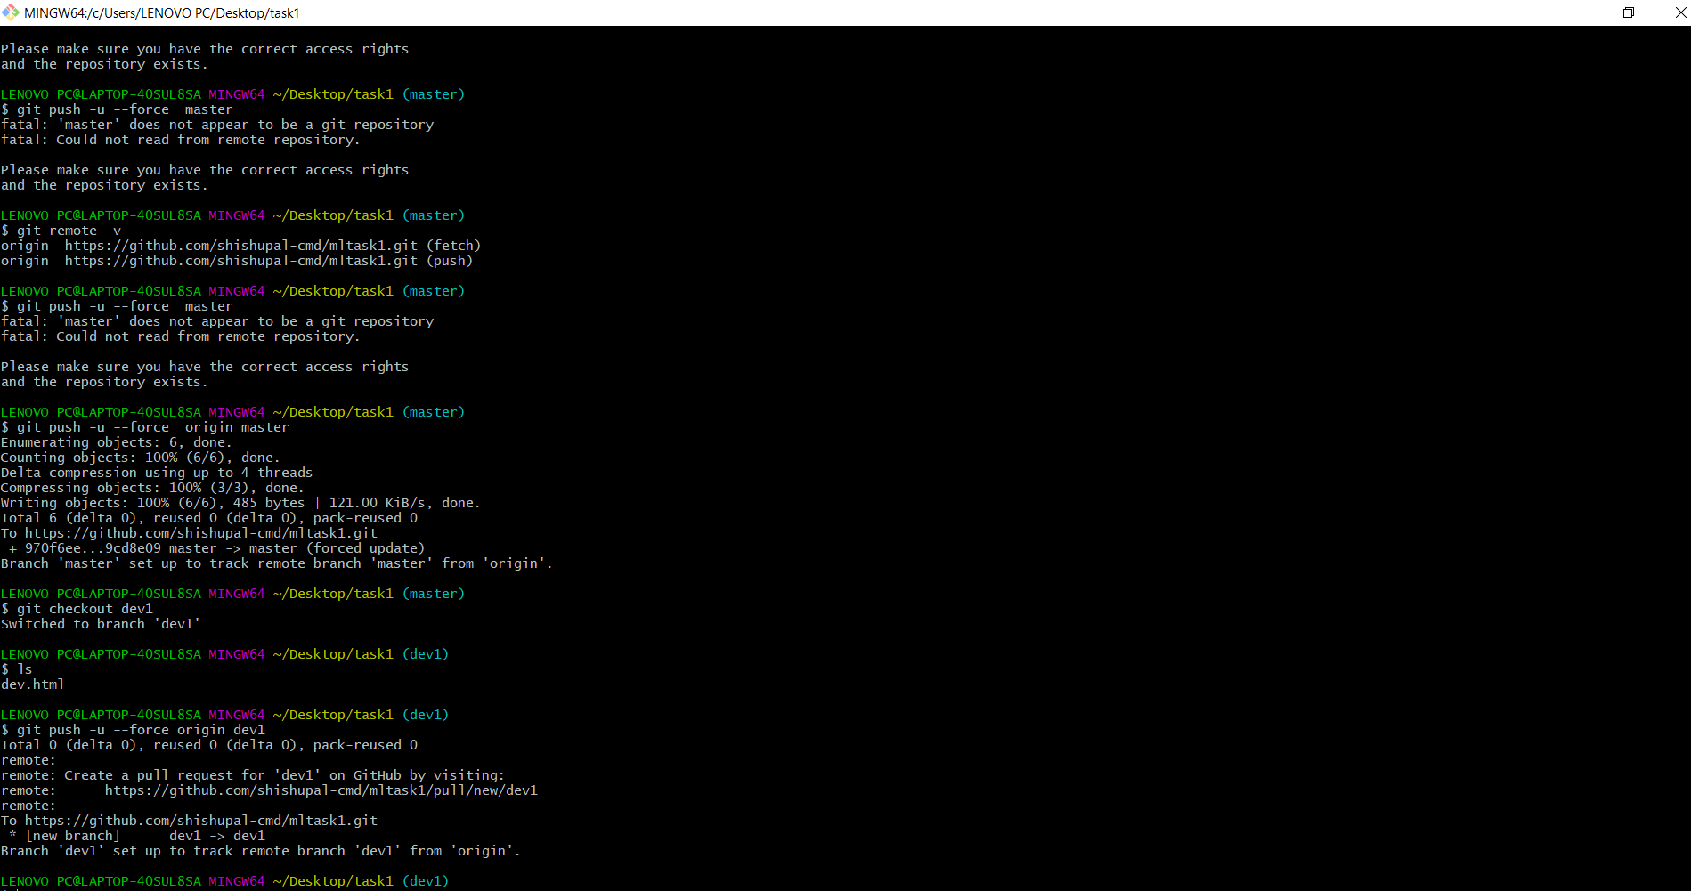

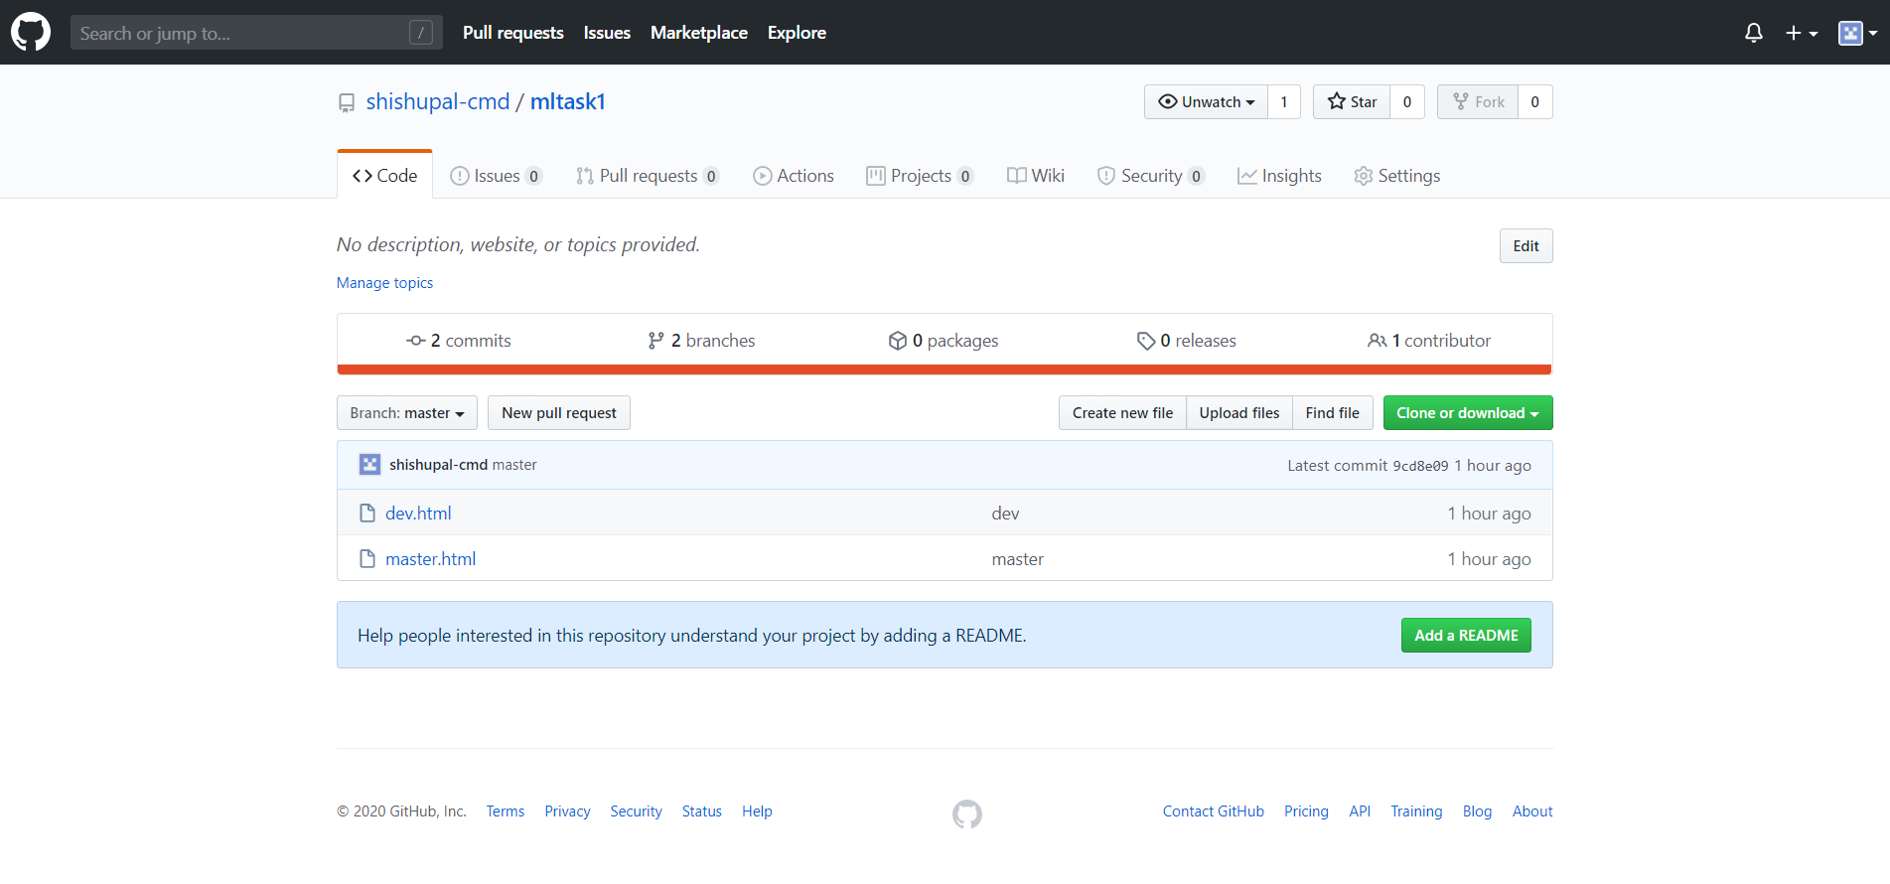

We have to create test_env and prod_env to store the code of github from dev and master branch respectively and start the httpd , docker and disable the firewall

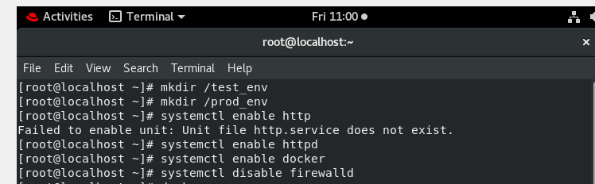

We have to create three jobs :

JOB 1 ->This job will pull the code from github , from the dev1 branch using the build trigger ,I have used the poll SCM as trigger and then copy the code to a directory test_env in RHEL8 . After pulling the I have checked for container dev_container ,if already running then it will remove it and then it run the container with the code . 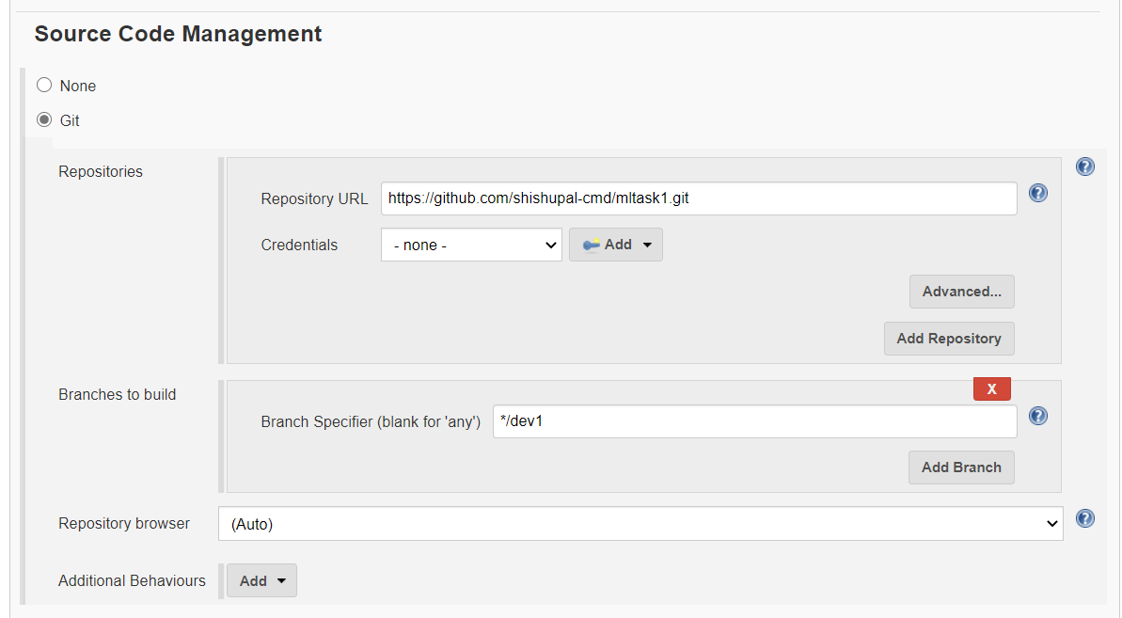

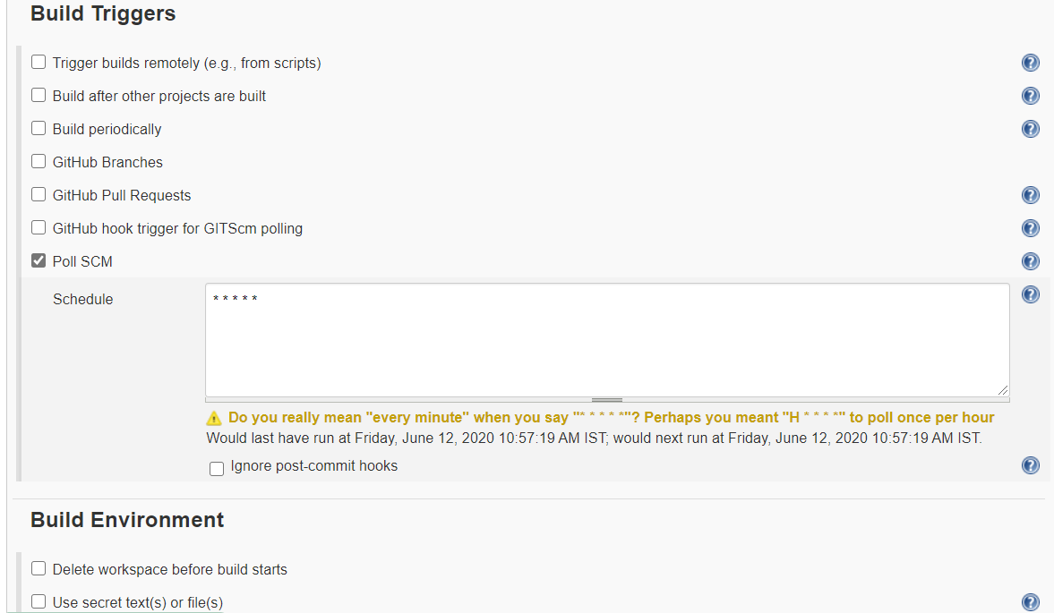

Here I have copied the code from test_env to /usr/local/htdocs ,this is directory where all webpages are kept . We have to do patting so that client can access

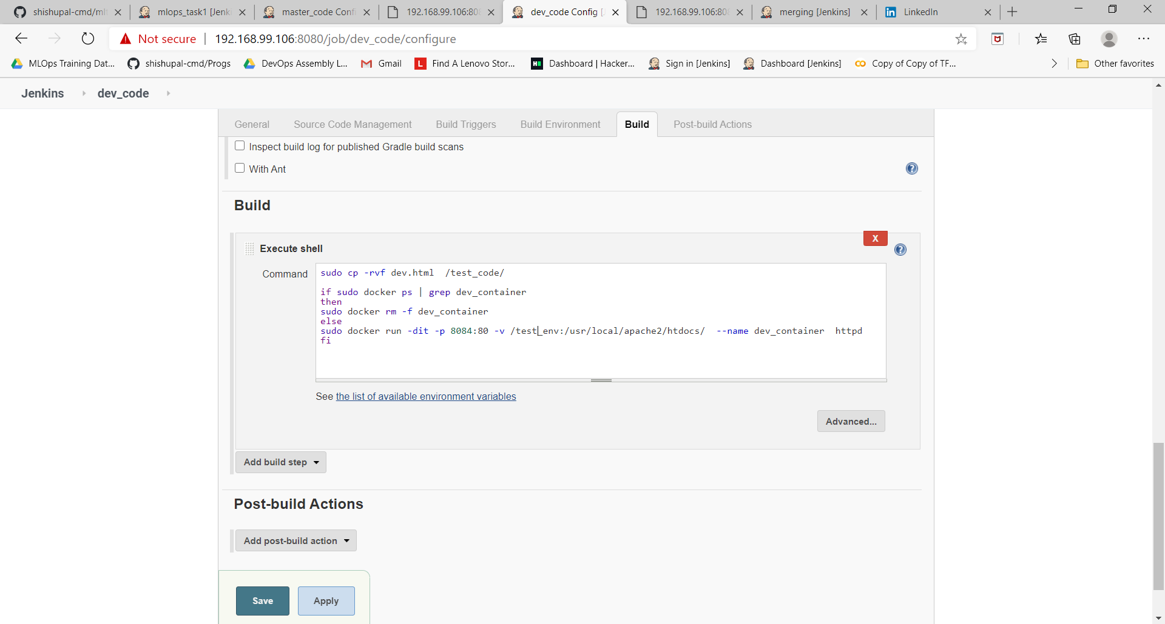

Here is output of code :

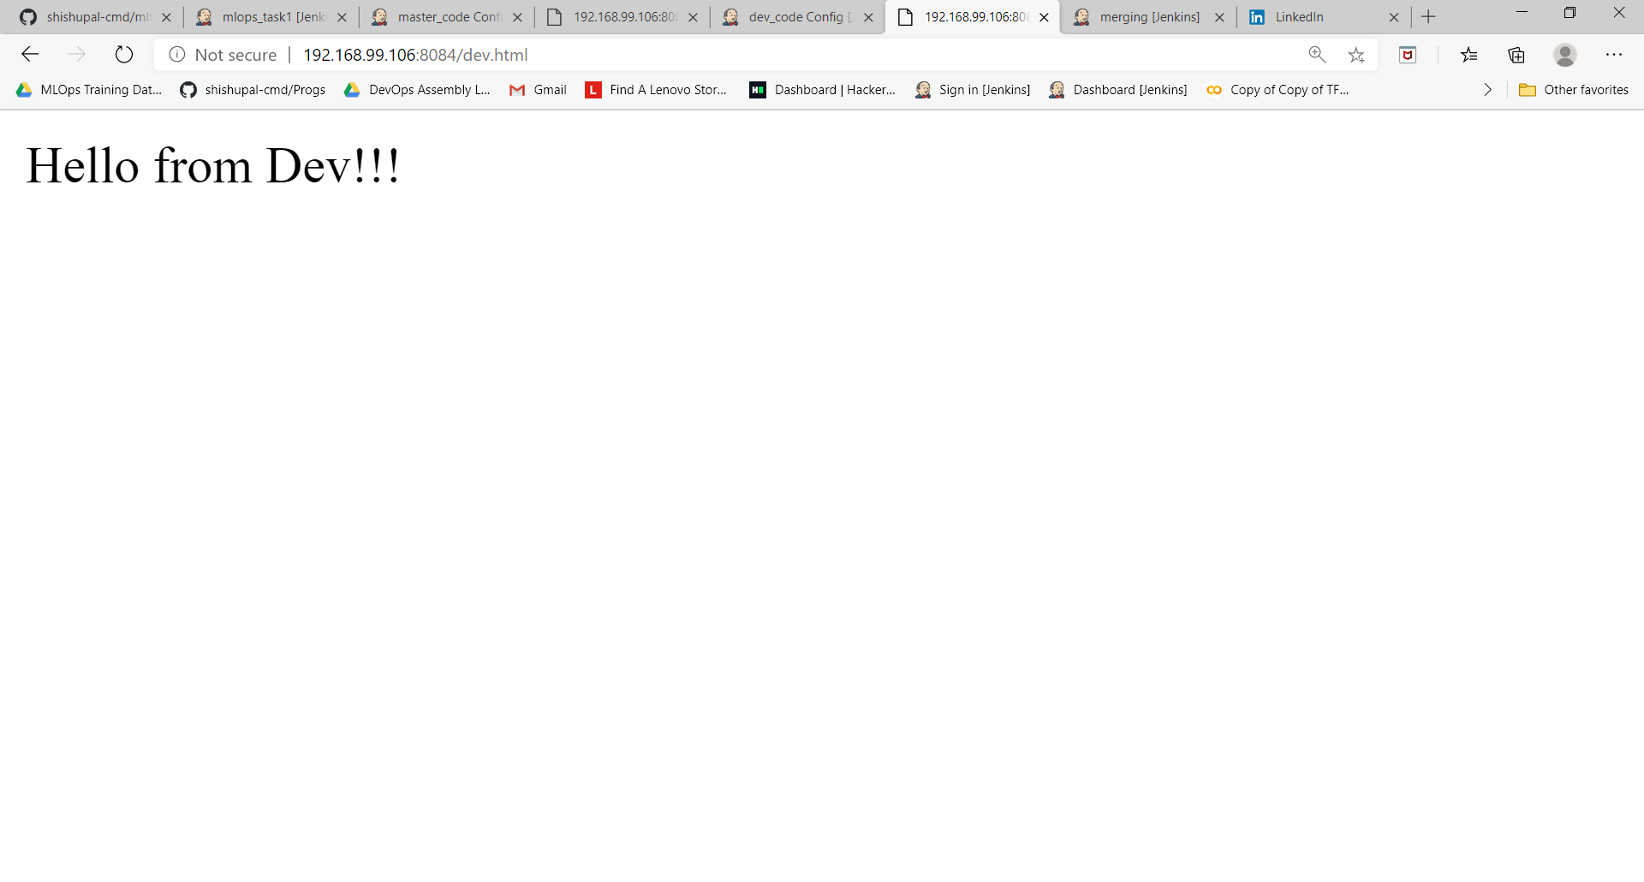

JOB 2 ->This job will pull the code from github , from the master branch using the build trigger ,I have used the poll SCM as trigger and then copy the code to a directory prod_env in RHEL8 . After pulling the I have checked for container master_container ,if already running then it will remove it and then it run the container with the code

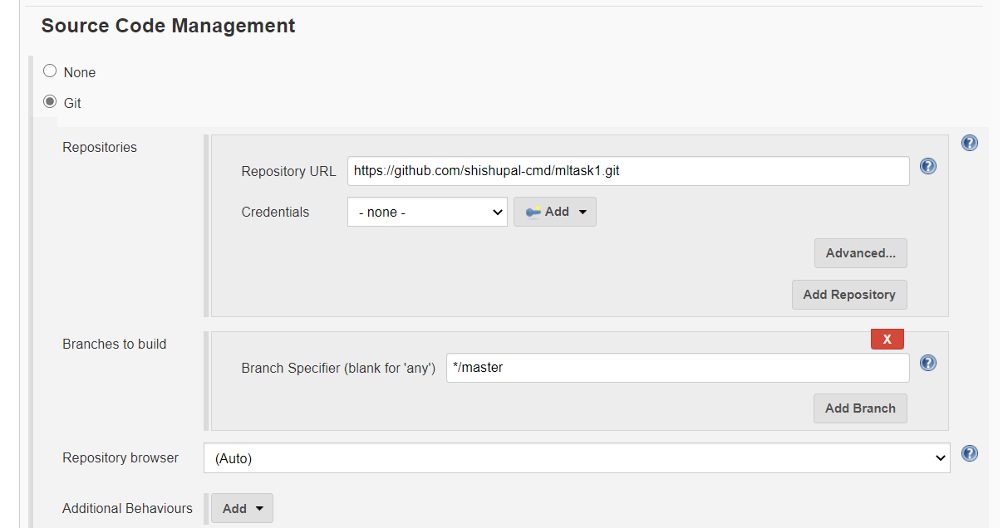

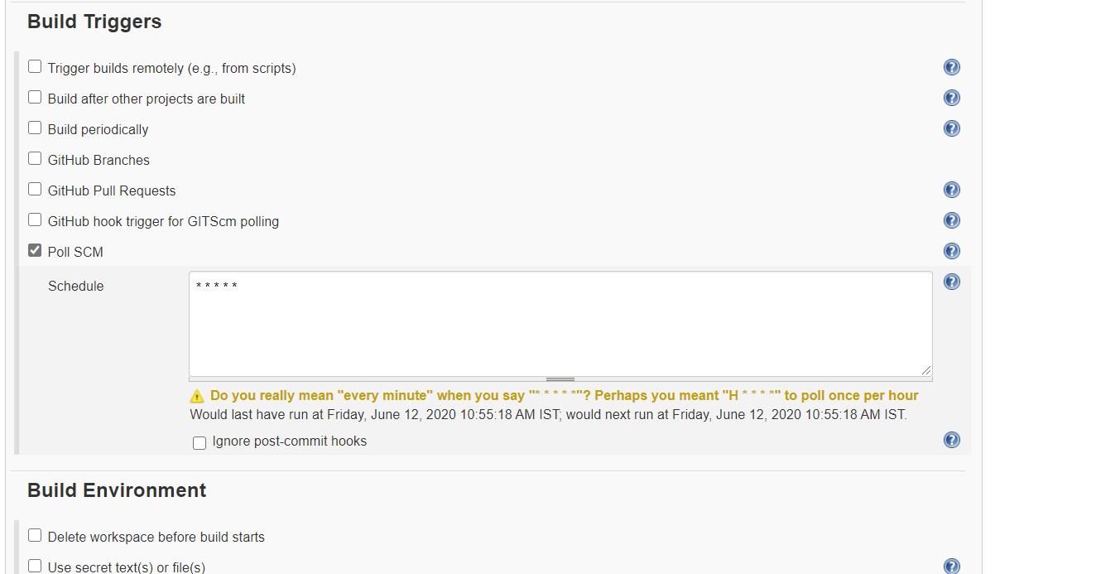

Here I have copied the code from prod_env to /usr/local/htdocs .Here also patting

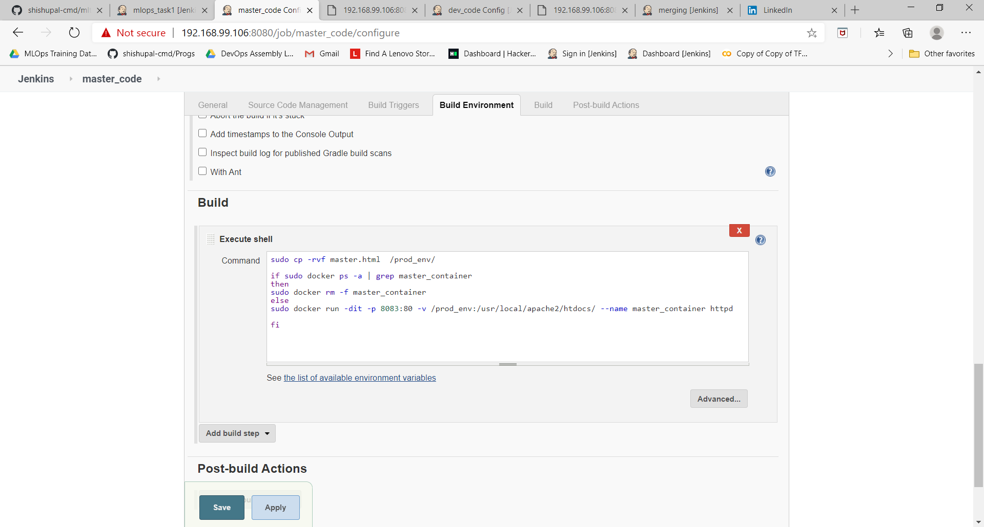

Here is the output of the code:

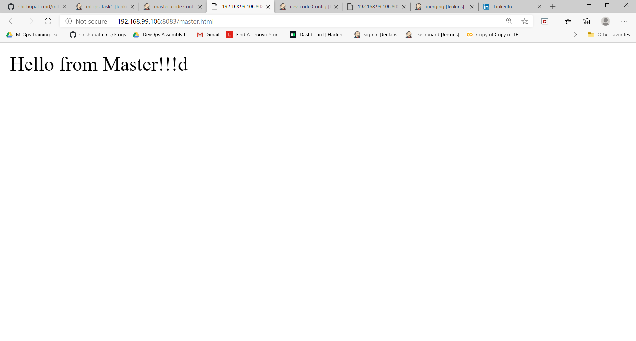

JOB 3 -> This Job will check if the dev_container is running fine then it will merge the master and dev branch and trigger the JOB 2.

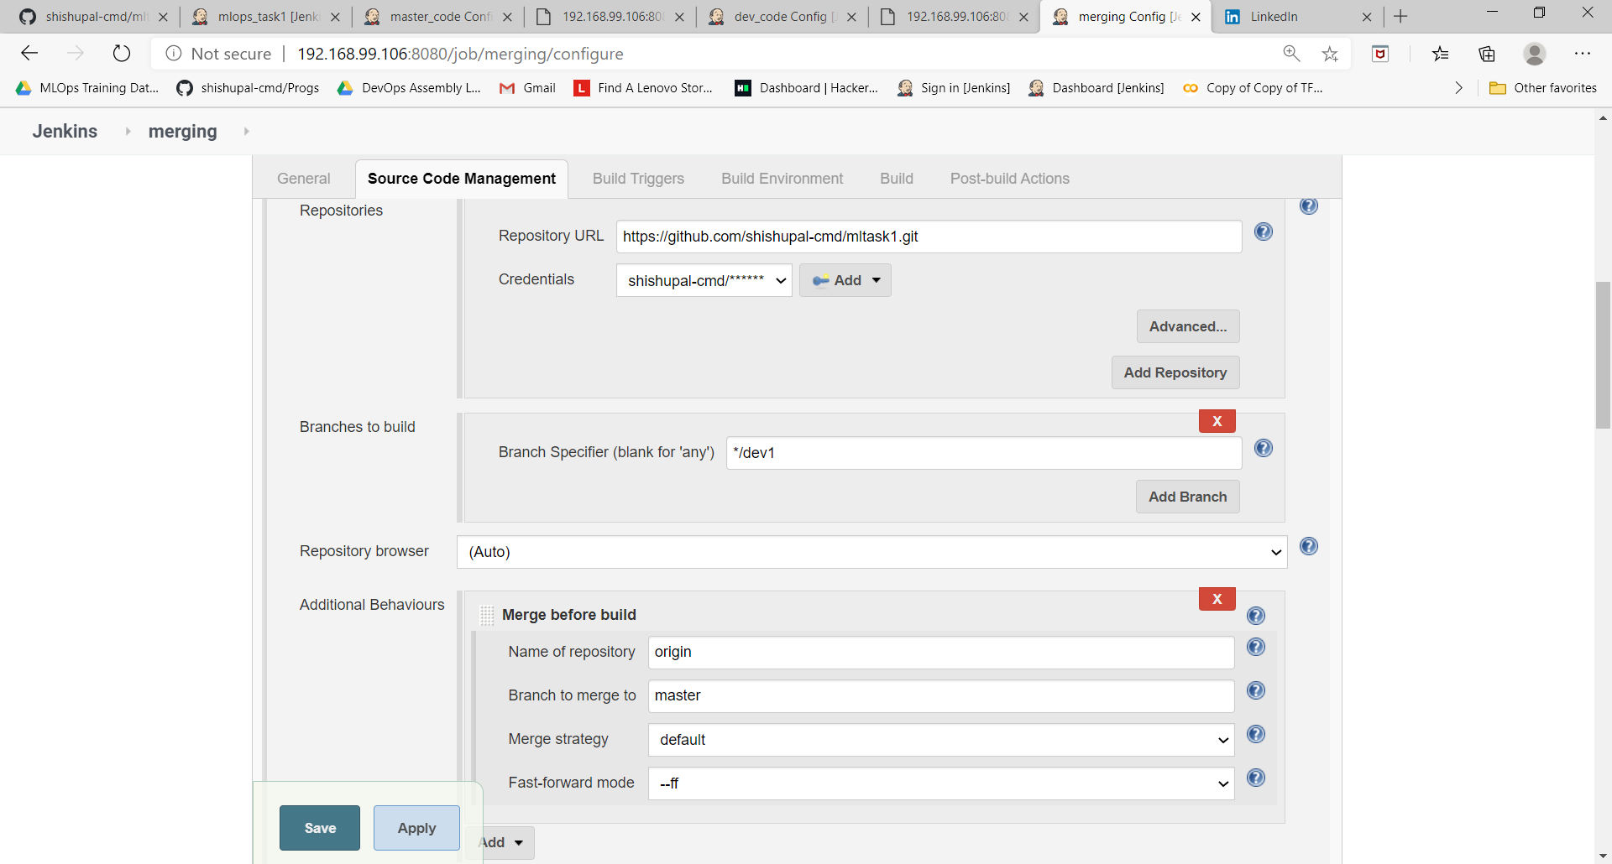

It will build after the dev_code or JOB 1 is built

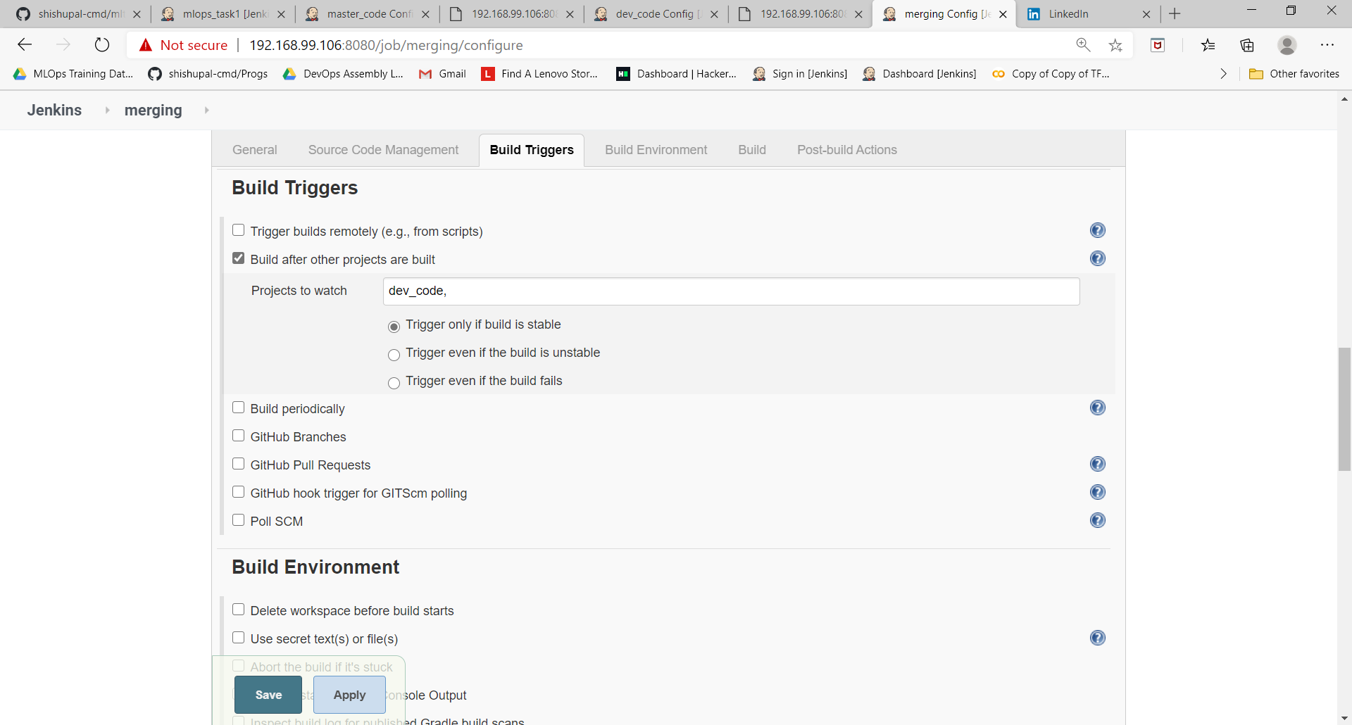

The master_code or JOB 2 is build after merging

